***A Mini Project Report on***

**Rain Prediction**

**T.E. - I.T Engineering**

**Submitted By**

**Adarsh Rai 20104039**

**Sahil Sawant 20104006**

**Raj Solkar 20104087**

**Under The Guidance Of**

**Prof. Mr. Ganesh Gourshete**



**DEPARTMENT OF INFORMATION TECHNOLOGY**

A.P.SHAH INSTITUTE OF TECHNOLOGY

G.B. Road, Kasarvadavali, Thane (W), Mumbai-400615

UNIVERSITY OF MUMBAI

**Academic year : 2022-23**

**CERTIFICATE**

This to certify that the Mini Project report on Rain Prediction has been submitted by Adarsh Rai 20104039, Sahil Sawant 20104006and Raj Solkar 20104087 who are a Bonafede students of A. P. Shah Institute of Technology, Thane, Mumbai, as a partial fulfilment of the requirement for the degree in **Information Technology**, during the academic year **2022-2023** in the satisfactory manner as per the curriculum laid down by University of Mumbai.

Prof. Mr. Ganesh Gourshete

Guide

Dr. Kiran Deshpande Dr. Uttam D.Kolekar

HOD , Information Technology Principal

External Examiner(s)

1.

2.

Place: A.P.Shah Institute of Technology, Thane

Date:

**ACKNOWLEDGEMENT**

This project would not have come to fruition without the invaluable help of our guide Prof. Mr. Ganesh Gourshete. Expressing gratitude towards our HoD, **Dr. Kiran Deshpande**, and the Department of Information Technology for providing us with the opportunity as well as the support required to pursue this project. We would also like to thank our teacher Ms. Charul Singh who gave us her valuable suggestions and ideas when we were in need of them. We would also like to thank our peers for their helpful suggestions.

**ABSTRACT**

A rain prediction system is a valuable tool that uses data from various sources to forecast the likelihood and amount of rainfall in a particular location. The system employs mathematical models and analyzes factors such as temperature, humidity, wind speed, and atmospheric pressure to provide accurate predictions of precipitation patterns. This technology has several benefits, including improved agricultural productivity, better water resource management, and enhanced disaster preparedness. However, it's important to remember that these systems are not infallible and can still experience errors and inaccuracies due to the unpredictable nature of weather patterns. Therefore, rain prediction systems should be used as just one tool in a broader strategy for managing weather-related risks.

**TABLE OF CONTENTS**

1.Introduction……………………………………………………………………..1

* 1. Purpose..................................................................................................... 1
  2. Problem Statement………………………………………………………2
  3. Objectives................................................................................................. 2
  4. Scope........................................................................................................ 3

1. Literature Review………………………………………………………………...4
2. Proposed System……….........................................................................................7
   1. Features and Functionality………………………………………………7
3. Requirements Analysis......................................................................................... 9
4. Project Design.......................................................................................................10
   1. Use Case diagram……………………………………………………… 10
   2. DFD (Data Flow Diagram) ……………………………………………..11
   3. System Architecture……………………………………………………..12
5. Technical specification……………...…………………………………………...13
6. Project Scheduling.................................................................................................15
7. Implementation…………………………………………………………………..16

9. Result and Discussion…………………………………………………………….17

1. Conclusion and FutureScope.................................................................................18

References

**Chapter 1**

**INTRODUCTION**

A rain prediction system using machine learning is a type of artificial intelligence (AI) technology that can forecast precipitation by analyzing various weather parameters such as temperature, humidity, wind speed, and atmospheric pressure. This type of system is designed to learn patterns from historical data and use them to make accurate predictions of when and where rain is likely to occur in the future.

The system typically works by processing large amounts of historical weather data and using machine learning algorithms to identify patterns and relationships between different variables. It then uses this information to develop a predictive model that can forecast the likelihood of rain in a given area at a particular time.

The rain prediction system can be integrated into various applications such as agriculture, transportation, and emergency management. For example, farmers can use the system to plan their crops' irrigation, while transportation companies can use the system to avoid weather-related disruptions. Additionally, emergency management agencies can use the system to prepare for potential flooding and other weather-related disasters.

Overall, a rain prediction system using machine learning has the potential to provide valuable insights and information to help individuals and organizations better prepare for and respond to weather-related events.

Rain prediction is an important application of machine learning that can help in various fields such as agriculture, transportation, and disaster management. Machine learning models can analyze various weather parameters such as temperature, humidity, wind speed, and atmospheric pressure, to predict whether it is going to rain or not.

**1.1 Purpose**

The purpose of a rain prediction system using machine learning is to accurately forecast the occurrence and intensity of rain in a particular area over a given period of time. This can help various industries and sectors to plan their activities and operations accordingly.

For example, farmers can use rain prediction systems to plan their irrigation schedules and crop planting, transport companies can plan their routes and schedules based on the weather forecast, and disaster management agencies can prepare for potential flood situations.

Machine learning algorithms can analyze large amounts of historical weather data, such as temperature, humidity, wind speed, and pressure, to detect patterns and make predictions about future weather conditions. The system can continuously learn and adapt based on new data, improving the accuracy of the predictions over time.

By using a rain prediction system based on machine learning, we can better prepare and manage our daily activities and mitigate potential risks associated with heavy rainfall or flooding.

**1.2 Problem Statement**

The problem statement of a rain prediction system using machine learning is to accurately predict the occurrence, intensity, and duration of rainfall in a given area, based on historical weather data, and other relevant variables such as temperature, humidity, wind speed, and pressure.

This involves addressing several challenges, such as dealing with data quality issues, selecting appropriate features for the model, choosing the right machine learning algorithm, and optimizing the model's hyperparameters.

Moreover, it is essential to keep updating the system with new data to ensure the model's accuracy and reliability, considering weather patterns can vary significantly over time.

Another significant challenge is dealing with the uncertainty associated with weather forecasting, and this can be addressed by incorporating probabilistic methods to quantify the level of uncertainty associated with the predictions.

Therefore, the goal of the rain prediction system using machine learning is to develop a reliable and accurate model that can help users make informed decisions and take appropriate actions based on the weather forecast.

The rain prediction system must be able to analyze large amounts of historical weather data and identify patterns and relationships between different variables, such as temperature, humidity, pressure, and wind speed. The system must also take into account the geographic features of the area, such as mountains, valleys, and coastlines, which can influence weather patterns.

**1.3 Objective**

The main objective of a rain prediction system using machine learning is to provide accurate and reliable predictions of rainfall patterns in a specific geographic area. This objective can be broken down into several specific goals, such as:

1. Improve the accuracy of rainfall predictions: The rain prediction system must be able to analyze historical weather data and identify patterns and trends to improve the accuracy of rainfall predictions. This will enable various industries to better plan their activities and operations based on expected rainfall patterns.
2. Reduce the impact of extreme weather events: By accurately predicting rainfall patterns, the rain prediction system can help to reduce the impact of extreme weather events such as floods and landslides, which can cause significant damage and loss of life.
3. Enable efficient resource allocation: The rain prediction system can help various industries to allocate their resources more efficiently based on expected rainfall patterns. For example, farmers can optimize their irrigation schedules, and transportation companies can adjust their routes and schedules to avoid areas that are likely to be affected by heavy rainfall.
4. Continuously learn and improve: The rain prediction system must be able to continuously learn and adapt based on new data and changing weather patterns. This will enable the system to improve its accuracy over time and provide more reliable predictions.
5. Support decision-making: The rain prediction system can support decision-making by providing accurate and timely information on expected rainfall patterns. This information can be used by government agencies, disaster management organizations, and other stakeholders to make informed decisions and take appropriate action.

**1.4 Scope**

The scope of a rain prediction system using machine learning is quite broad, as it can be applied to a wide range of industries and applications. Some of the main areas where the system can be used include:

1. Agriculture: Farmers can use the rain prediction system to optimize their irrigation schedules and plan their crop planting based on expected rainfall patterns.
2. Transportation: The system can help transportation companies to plan their routes and schedules based on expected weather conditions, including rainfall, to avoid areas that may be affected by heavy rain or flooding.
3. Disaster management: The system can support disaster management organizations to prepare for and respond to extreme weather events, such as floods and landslides, by providing accurate and timely information on expected rainfall patterns.
4. Urban planning: The system can be used to inform urban planning decisions, such as the location of infrastructure and buildings, based on expected rainfall patterns and flood risk.
5. Renewable energy: The system can help renewable energy companies to plan the deployment of solar and wind power systems based on expected weather patterns, including rainfall.

**Chapter 2**

**2. Literature Review**

|  |  |  |  |  |  |  |
| --- | --- | --- | --- | --- | --- | --- |
| **Sr.no** | **Title** | **Author(s)** | **Year** | **Algorithms** | **Limitations** | **Result** |
| 1 | An Application of Neural Networks for Rainfall  Prediction | Kin C. Luk, J.E. Ball and A. Sharma | 2001 | Multiple Regression Techniques were used inside a neural network | It involves very lengthy and complicated procedure of calculations and analysis | Result was accurate and can be used for prediction in future |
| 2 | Computational Analysis of Neural Network Model | A.C. Subhashini and V. Joseph Raj | 2010 | Back propagation algorithm was used in this model | The model is quiet sensitive to noisy data and that’s why there is hinderance in results | Back propagation has proven to be useful in this study |
| 3 | Temperature Forecasting based on Neural Network Approach | Mohsen Hayati and Zahra  Mohebi | 2007 | They tested using real time dataset and used back propagation algorithm | The model takes a large time for computation of result. More time is used in this process | Their model had potential to forecast temperature |

**Chapter 3**

**3. Proposed System**

A proposed rain prediction system using machine learning could consist of the following components:

1. Data collection: The system would need to collect and store historical weather data, such as rainfall measurements, temperature, humidity, wind speed, and other relevant variables. This data could be obtained from weather stations, satellite imagery, and other sources.
2. Data preprocessing: The collected data would need to be preprocessed to remove noise, handle missing values, and perform feature engineering to extract relevant features for rainfall prediction. Various techniques such as data normalization, dimensionality reduction, and data imputation could be used for data preprocessing.
3. Machine learning model development: The system would need to develop and train machine learning models to predict rainfall patterns based on the preprocessed data. Various algorithms such as ANNs, SVMs, Decision Trees, and Random Forest could be evaluated and compared to determine the best performing model for the specific application.
4. Model evaluation: The performance of the machine learning models would need to be evaluated using appropriate metrics such as mean absolute error, root mean squared error, and correlation coefficient. The evaluation results would provide insights into the accuracy and reliability of the model for predicting rainfall.
5. Model deployment: Once the best performing machine learning model is identified and evaluated, it can be deployed in the system for predicting rainfall in real-time. The deployed model would take in input data such as current weather conditions and provide an output prediction of expected rainfall.
6. User interface: The system could provide a user-friendly interface for users to interact with the system, view rainfall predictions, and access other relevant information such as historical weather data, weather alerts, and flood risk assessments.

**3.1 Features and Functionality**

The features and functionality of a rain prediction system using machine learning could include the following:

1. Real-time prediction: The system could provide real-time predictions of rainfall patterns based on the current weather conditions and historical data.
2. Accurate predictions: The system would use machine learning algorithms to provide accurate predictions of rainfall with low error rates.
3. Customizable alerts: The system could provide customizable alerts to users based on their location and the severity of the predicted rainfall. Users could set thresholds for rainfall intensity or duration to receive alerts.
4. Historical data analysis: The system could provide access to historical weather data and analysis tools to help users better understand weather patterns and make informed decisions.
5. Flood risk assessment: The system could provide flood risk assessments based on predicted rainfall patterns and historical data to help users identify areas of high risk and take appropriate actions.
6. User-friendly interface: The system could provide a user-friendly interface for users to interact with the system, view rainfall predictions, and access other relevant information such as weather alerts and flood risk assessments.
7. Multiple sources of data: The system could use multiple sources of data, such as weather stations, satellite imagery, and other sources, to improve the accuracy of predictions.
8. Scalability: The system could be designed to handle large volumes of data and be easily scalable to accommodate changing data volumes and user demands.

Overall, a rain prediction system using machine learning could provide accurate and reliable predictions of rainfall patterns, customizable alerts, historical data analysis, flood risk assessments, and a user-friendly interface for various applications and industries.

**CHAPTER 4**

**4. Requirements Analysis**

Requirements analysis for a rain prediction system involves identifying and defining the functional and non-functional requirements of the system. Here are some key requirements that should be considered for a rain prediction system:

Functional Requirements:

1. Data collection: The system should be able to collect historical weather data from various sources.
2. Data preprocessing: The system should be able to clean and preprocess the data to remove any missing or inaccurate values.
3. Feature engineering: The system should be able to create new features from the existing data that can help improve the accuracy of the rain prediction model.
4. Model training: The system should be able to train a model that can accurately predict rainfall based on the historical weather data.
5. Model evaluation: The system should be able to evaluate the performance of the model and provide metrics that indicate the accuracy of the predictions.
6. Prediction generation: The system should be able to generate accurate predictions of rainfall based on the input data.

Non-Functional Requirements:

1. Performance: The system should be able to generate predictions quickly and efficiently.
2. Accuracy: The system should be able to generate accurate predictions of rainfall.
3. Reliability: The system should be reliable and able to handle large amounts of data without crashing.
4. Scalability: The system should be able to handle large amounts of data and be able to scale up as needed.
5. Security: The system should be secure and protect the data from unauthorized access.
6. Usability: The system should be easy to use and understand for non-technical users.

Overall, a rain prediction system should be designed to accurately predict rainfall based on historical weather data. It should be reliable, scalable, and secure, while also providing users with a simple and easy-to-use interface. By meeting these requirements, the rain prediction system can provide valuable

**CHAPTER 5**

**5.Project Design:**

Developing a training model for rain prediction involves several steps, including data preprocessing, feature engineering, model selection, model training, and model evaluation. Here are some steps to develop a training model for rain prediction:

Data Preprocessing: Clean the data by removing any missing or inaccurate values, and normalize the data to ensure that all variables are on the same scale. This may involve filling in missing values, removing outliers, and scaling the data.

Feature Engineering: Create new features from the existing data that can help improve the accuracy of the rain prediction model. For example, you can calculate the mean, median, or standard deviation of rainfall over a certain period.

Model Selection: Select an appropriate machine learning algorithm for rain prediction, such as linear regression, decision trees, or neural networks. This should be based on the requirements and constraints of the system, as well as the accuracy and performance of the algorithm.

Model Training: Split the data into training and testing sets, and use the training data to train the selected model. This involves selecting the best hyperparameters for the algorithm and tuning the model to improve its performance.

Model Evaluation: Evaluate the performance of the model using the testing data. This involves calculating metrics like accuracy, precision, recall, and F1 score to determine how well the model is performing.

Here are some specific steps for developing a linear regression model for rain prediction:

Load the data: Load the cleaned and preprocessed data into the model. This data should include information about rainfall, temperature, humidity, wind speed, and other relevant variables.

Feature selection: Select the features that are most relevant for rain prediction. This may involve using techniques like correlation analysis, feature importance, or forward/backward selection.

Split the data: Split the data into training and testing sets. The training set is used to train the model, while the testing set is used to evaluate the model's performance.

Train the model: Train the linear regression model using the training data. This involves fitting the model to the training data and selecting the best hyperparameters for the algorithm.

Evaluate the model: Evaluate the performance of the model using the testing data. Calculate metrics like mean squared error, root mean squared error, and R-squared to determine how well the model is performing.

Improve the model: Improve the performance of the model by using techniques like regularization, feature selection, or ensemble methods.

devloping traing model for rain prediction using linear regression

Developing a training model for rain prediction using linear regression involves the following steps:

Data Collection: Collect historical weather data that includes information about rainfall, temperature, humidity, wind speed, and other relevant variables. This data can be obtained from meteorological departments, weather stations, or online sources.

Data Preprocessing: Clean the data by removing any missing or inaccurate values, and normalize the data to ensure that all variables are on the same scale.

Feature Engineering: Create new features from the existing data that can help improve the accuracy of the rain prediction model. For example, you can calculate the mean, median, or standard deviation of rainfall over a certain period.

Model Selection: Select linear regression as the machine learning algorithm for rain prediction. Linear regression is a simple and effective method for predicting continuous variables like rainfall.

Split Data: Split the data into training and testing sets, usually in a 70-30 or 80-20 ratio. This allows you to evaluate the performance of the model on unseen data.

Train the Model: Train the linear regression model using the training data. This involves fitting the model to the training data and selecting the best hyperparameters for the algorithm.

**5.1. Use Case diagram:**

A use case diagram is a visual representation of the system's functionality from the perspective of the users. It outlines the various actions and interactions that users can perform within the system. Here is a use case diagram for the mini project on rain prediction system application using linear regression algorithm:

**5.2.DFD (Data Flow Diagram)**

**DFD Level 0:**

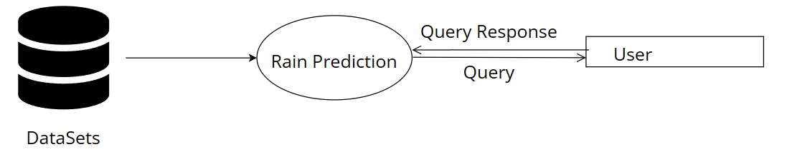

**DFD Level 1:**

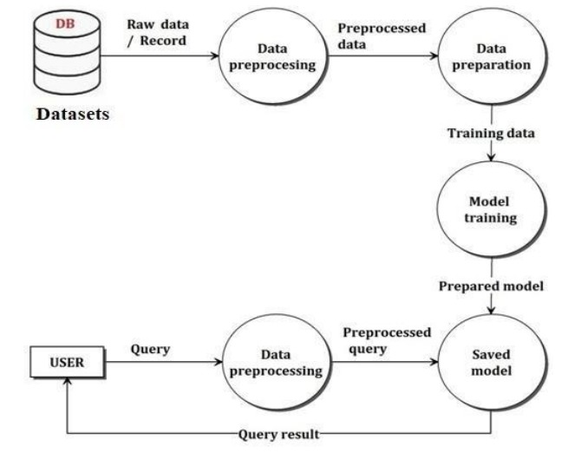

**5.3. System Architecture**

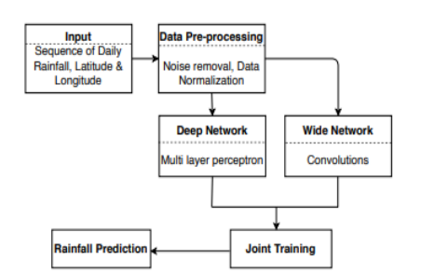

**Chapter 6**

**Technical Specification:**

**Hardware Required :**

1) Standard computer with at least i3 processor Standard computer with 4GB of RAM

2) Standard computer with 100GB of free space

3) Active Internet Connectivity with good bandwidth

**Software Required :**

1. Flask to integrate frontend & backend
2. Python libraries like
3. Front-End: HTML, CSS, Bootstrap
4. IDE: Jupyter notebook, Pycharm

**Operating System :**

1. Windows 10 / 11

Chapter 7

7. Project Scheduling :

|  |  |  |  |
| --- | --- | --- | --- |
| **Sr. No** | **Group Member** | **Time duration** | **Work to be done** |
| **1** | Adarsh Rai | 1st week of january | Implementing GUI and connecting camera accessibility/Designing a user friendly interface which displays web pages of Rain Prediction and establishing browser camera connection |
| 2nd week of january | Testing GUI and Camera/ checking proper routing and interactions of web pages in application and testing opencv accessibility |
| **2** | Raj Solkar | 3rd week of january | Implementing spearman Model / adding a Kaggle(Autralia.csv) datasets and classifying Kaggle according to time, temp  Wind gust, tamp at different times |
| **3** | Sahil Sawant | By the end of march month | Implementing spearman Model/ showcasing accuracy of seabun and key-points with percentage |

**Chapter 8**

**Implementation**

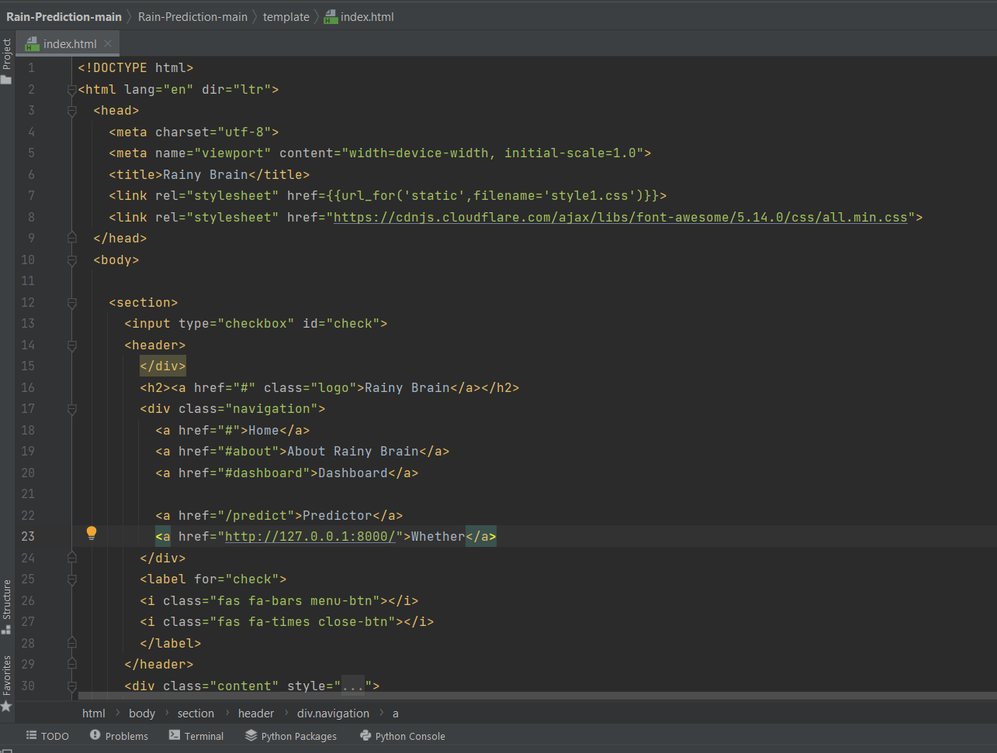

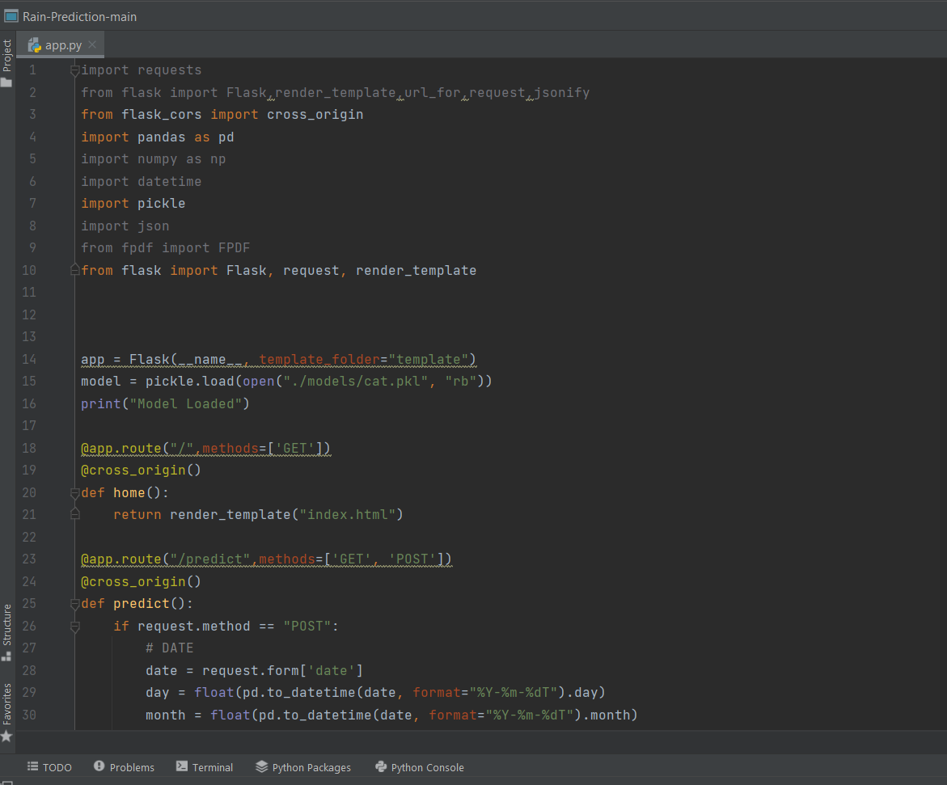

**Chapter 9**

**9.Result and Discussion**

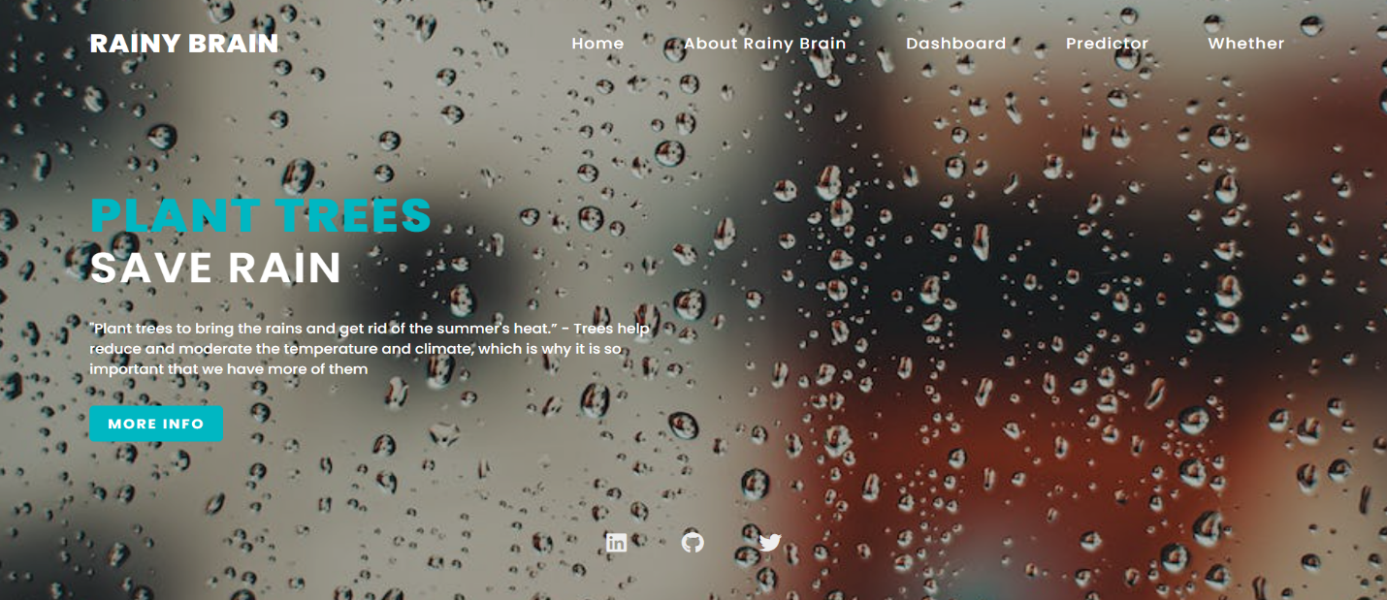



**Chapter 10**

**10. Conclusion and Future Scope**

A rain prediction system is a valuable tool that uses various data sources and mathematical models to forecast the likelihood and amount of rainfall in a given location. By analyzing factors such as temperature, humidity, wind speed, and atmospheric pressure, such systems can provide accurate predictions of precipitation patterns, helping farmers, city planners, and emergency responders prepare for potential weather-related risks.

Overall, a well-designed rain prediction system can offer numerous benefits to society, such as improved agricultural productivity, better water resource management, and enhanced disaster preparedness. However, it's important to keep in mind that such systems are not foolproof and can still experience errors and inaccuracies due to the unpredictable nature of weather patterns. Therefore, it's crucial to use rain prediction systems as just one tool in a broader strategy for managing weather-related risks.

**References:**

1. National Oceanic and Atmospheric Administration (NOAA) - This is a US-based government agency that provides weather forecasts and warnings. Their website, https://www.noaa.gov/, includes a range of weather-related information and tools, including a precipitation map that can help with rain prediction.
2. European Centre for Medium-Range Weather Forecasts (ECMWF) - This is an independent organization that provides weather forecasts and predictions for Europe and other parts of the world. Their website, https://www.ecmwf.int/, includes information on their forecasting methods and tools, which can be useful for rain prediction.
3. The Weather Channel - This is a popular weather-related website and app that provides weather forecasts and predictions for various locations around the world. Their website, https://weather.com/, includes a range of tools and features, such as radar maps, that can be helpful for rain prediction.
4. AccuWeather - This is another popular weather-related website and app that provides weather forecasts and predictions. Their website, https://www.accuweather.com/, includes a range of tools and features, such as MinuteCast®, that can be useful for predicting rain in specific locations.